SPOKANE COUNTY FIRE DISTRICT NO. 13
Newman Lake Fire & Rescue

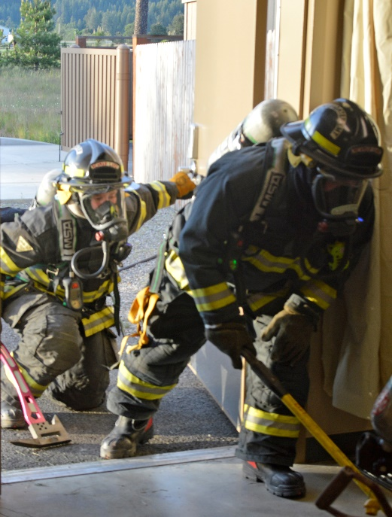

June 8, 2023

SPECIAL MEETING
1:00 PM

STATION 1
9324 N. Starr Road
NEWMAN LAKE, WA 99025

